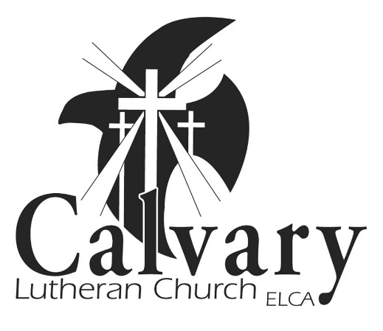
Safe Haven for
Children, Youth &
Vulnerable Adults
Safety & Abuse
Prevention Policy

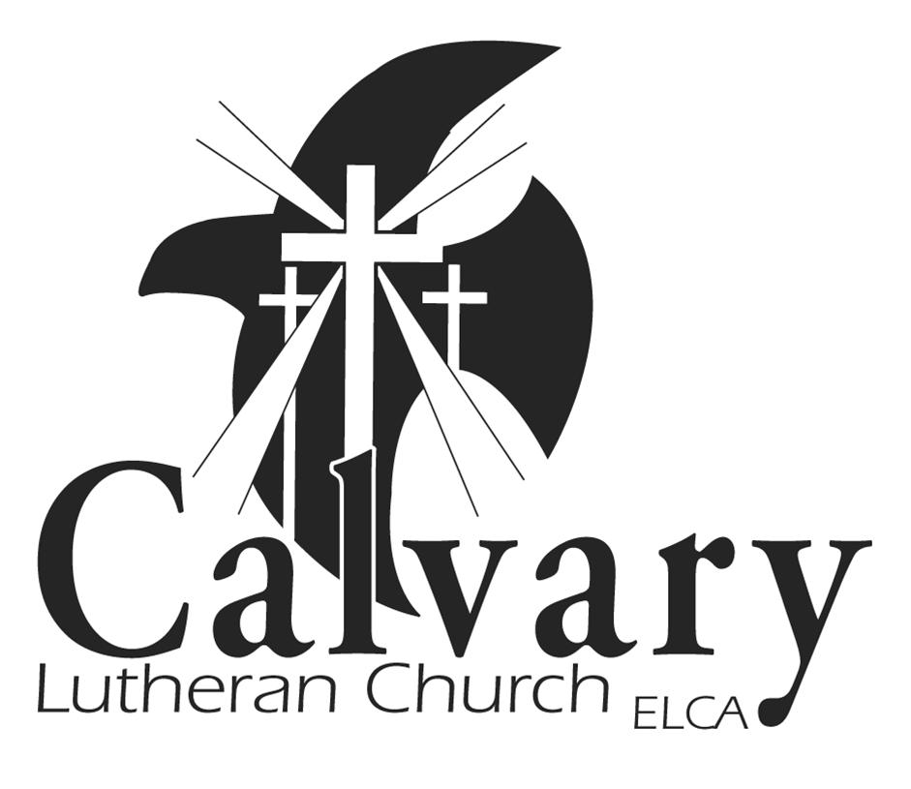

Calvary Lutheran Church
2508 Washington Ave. Bemidji, MN 56601
phone 218.751.1893 www.calvarybemidji.org
FINAL: 07/10/2013; REVISED 10/2017
Calvary Lutheran Church of Bemidji

Safe Haven for
Children, Youth & Vulnerable Adults

Table of Contents

Covenant . . . . . . . . . . . . . . . . . . . . . . . . . . . . . . . . . . . . . . . . . . . . . . . . . . . . . . . . . . . . . . . . . 3

Calvary’s Commitment . . . . . . . . . . . . . . . . . . . . . . . . . . . . . . . . . . . . . . . . . . . . . . . . . . . . . . . . 4

Marks of a Safe Haven . . . . . . . . . . . . . . . . . . . . . . . . . . . . . . . . . . . . . . . . . . . . . . . . . . . . . . . . . 5

Definition of Child Abuse . . . . . . . . . . . . . . . . . . . . . . . . . . . . . . . . . . . . . . . . . . . . . . . . . . . . . . . 6

Definition of Vulnerable Adult . . . . . . . . . . . . . . . . . . . . . . . . . . . . . . . . . . . . . . . . . . . . . . . . . . . 7

Calvary’s Procedure for Preventing Abuse . . . . . . . . . . . . . . . . . . . . . . . . . . . . . . . . . . . . . . . . . . 8

Calvary’s Leadership Expectations . . . . . . . . . . . . . . . . . . . . . . . . . . . . . . . . . . . . . . . . . . . . . . . . . 8

Volunteer Screening Process . . . . . . . . . . . . . . . . . . . . . . . . . . . . . . . . . . . . . . . . . . . . . . . . . . . . . 8

Guidelines for Calvary Volunteers . . . . . . . . . . . . . . . . . . . . . . . . . . . . . . . . . . . . . . . . . . . . . . . . 9

Onsite Guidelines . . . . . . . . . . . . . . . . . . . . . . . . . . . . . . . . . . . . . . . . . . . . . . . . . . . . . . . . . . . . 10

Emergency Procedures . . . . . . . . . .. . . . . . . . . . . . . . . . . . . . . . . . . . . . . . . . . . . . . . . . . . . . . . . 11

Responsibility for Reporting Abuse . . . . . . . . . . . . . . . . . . . . . . . . . . . . . . . . . . . . . . . . . . . . . . . 11

Minnesota State Law on Reporting Child Abuse . . . . . . . . . . . . . . . . . . . . . . . . . . . . . . . . . . . . . 12

Blank Notes Page . . . . . . . . . . . . . . . . . . . . . . . . . . . . . . . . . . . . . . . . . . . . . . . . . . . . . . . . . . 13

Appendix A: Desirable & Undesirable Behaviors. . . . . . . . . . . . . . . . . . . . . . . . . . . . . . . . . . . 14

Appendix B: Procedures……………………………………………………………………….. 16

Form A (for applications) ……………………………………………………………………… 19

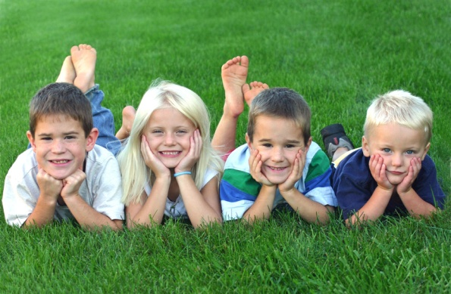

Covenant to Be a Safe Haven for
Children, Youth & Vulnerable Adults

We, the members of
Calvary Lutheran Church
living out our faith at

2508 Washington Ave.
Bemidji, MN 56601

affirm our commitment to be a

Safe Haven for
Children, Youth and Vulnerable Adults

Knowing that living in this covenant is a lifelong process
of learning and caring, and knowing that we work with others in our immediate community, the wider church and the world to develop programs and places where all people can flourish,
we ask God to help us.

“Children are a blessing & gift from God.”
(Psalm 127:3)

Calvary’s commitment

“But Jesus called the children to him and said, ‘Let the little children come to me, and do not hinder them, for the kingdom of God belongs to such as these.’” – Luke 18:16

As we are “Gathered to Worship; Transformed by Christ; and Sent Out to Serve” we will care for all people within Calvary. It is the policy of Calvary Lutheran Church, Bemidji, to provide a safe environment for the children, youth and workers in our church. Ministry to our children, youth and vulnerable adults is deeply valued and to that end, procedures will be followed to protect them from harm in our church.

Calvary Lutheran Church is a community of faith that cherishes our children and youth and values their individual contributions to our growth as Christians. Keeping the young people as well as the staff and volunteers of our church safe is a top priority.

Because the legal and social environment of our society is turbulent and changing rapidly, it shall be our policy to monitor this external environment in light of our vision to “be a beacon for Christ in our community.” As a Christian body, we shall be proactive in reviewing our policies and procedures to make changes when necessary to provide a safe environment for the children, youth, vulnerable adults, volunteers and staff of our church.

Definitions:
Children: those under 12 years of age
Youth: those at least 12 years old, not yet 18 or still in high school
Calvary Ministry Team Leads/Staff: those who are paid by Calvary Lutheran Church
Volunteers: those who enter into or offer themselves for a church related service, or who assist with or perform a service, whether or not they have been selected or assigned to do so
Vulnerable Adult: a person who is 18 years or older and who fits the criteria of either categorical vulnerable adult or functional vulnerable adult (see page 5)

Why is a safety and abuse policy necessary?

- To Protect Children, Youth & Vulnerable Adults —
The creation of a secure, safe environment for our youth is of utmost importance (Matthew 18:1-10). The application, training and reference check processes are all screening procedures to assure the safety of our children.

- To Protect Volunteers and Staff —
It is necessary to protect church staff and volunteer workers from potential meritless allegations of abuse.

- To Raise Awareness Level —
The goal is not to raise suspicion, but to become educated about the process and systems regarding protection of people at Calvary Lutheran Church.

- Calvary’s Position in the Community —
Because we are a leader in the greater Bemidji community, we need to be the best advocates for children, youth and vulnerable adults we can be.

- Legal Protection of Calvary Lutheran Church —
There are several liability factors that dictate how we process our volunteers and paperwork.

Parental/Guardian Responsibility
All parents should be encouraged to assume individual responsibility for their children and not assume the church sponsored activity or presence on the church premises is a guarantee of the child’s safety. Children should not be left unattended in the church building.
Marks of a safe haven (What we imagine Calvary Lutheran can be)

What does a Safe Haven for Children, Youth and Vulnerable Adults look like? In Holy Baptism, we make commitment to “renounce the devil and all the forces that defy God…” (ELW, page 229). What are the “forces that defy God” that threaten the safety of children and vulnerable adults in our setting? How can our congregation boldly state its belief in a God who creates, redeems, and sanctifies? The following are characteristics of a Safe Haven for Children, Youth and Vulnerable Adults.

Children & vulnerable adults are safe from… A Safe Haven looks like…

• Physical abuse Zero tolerance of physical violence

• Sexual abuse Zero tolerance of sexual abuse

• Emotional abuse Zero tolerance of emotional abuse

• Stifling stereotypes Zero tolerance of racism, sexism, ageism

• Hunger Immediate assistance in times of crisis

• Homelessness Understands the causes of poverty

• Rejection Allocates resources to create Safe Havens

• People are free from financial exploitation Zero tolerance of financial exploitation

Children & vulnerable adults are safe to A Safe Haven looks like…

• Grow in faith Worship is child/vulnerable adult-friendly

• Love God Worship is child/vulnerable adult-friendly

• Love their neighbors Strong relationships between generations

• Give Commitment to teach and learn from children & vulnerable adults
• Feel empathy Time is taken to talk with and listen to children & vulnerable adults
• Serve Challenged to grow in faith and service

• Discover High standards for quality care and
education
• Create Joy and fun, rather than boredom

• Hope Encouragement and enthusiasm

• Be aware of their community Strong connections both locally and globally

• Be aware of the world Seeing life through the eyes of a child or vulnerable adult
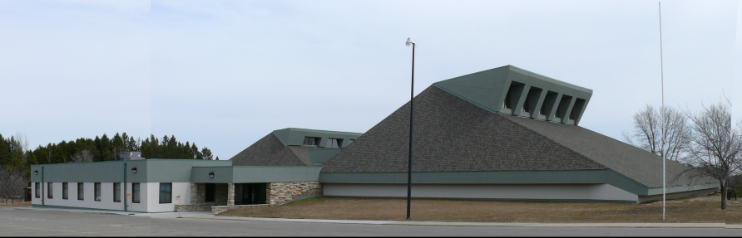

Types of child abuse
While child abuse has gotten more attention in the last few decades (it wasn’t until 1961 that the medical profession formally recognized child abuse), it is still a growing problem in our society. Child abuse can be described in four different categories: Physical, Mental, Sexual, and Neglect.
Physical Abuse
• Inflicting injury upon a child by other than accidental means, which causes death, disfigurement, impairment of physical or emotional health, or loss or impairment of any bodily function.
• Placing a child in a situation where they will likely be injured.
• Characterized by injury from punching, kicking, biting, burning or otherwise physically harming a child.
Mental Abuse
• Emotional, or psychological injury that causes, or could cause, behavioral, emotional, or mental disorders.
• Verbal comments, actions or statements that would cause a child to believe their person, emotions, physical form, family, race, background, religious background, or social status is somehow bad, inferior, unacceptable or shameful.
• Emotional abuse is almost always present with other types of abuse.
Sexual Abuse
• Child sexual abuse is any sexual activity with a child in any setting. The abuser may be an adult, an adolescent, or another child.
• Child sexual abuse may be violent or non-violent.
• Child sexual abuse is criminal behavior that involves children in sexual behaviors for which they are not personally, socially or developmentally ready.
• Child sexual abuse may include actual or threatened touching or non-touching behavior.
• Types of child sexual abuse that involve touching include the following: fondling; oral, genital or anal penetration; intercourse; forcible rape; etc.
• Types of child abuse that do not involve touching: pornographic pictures; obscene phone calls; exhibitionism; allowing children to view sexual activity, verbal comments, etc.
Neglect
• This can be physical, such as delay of nourishment or health care; educational, such as permitting a child to be truant from school; or emotional, such as extreme spousal abuse in front of the child; or failing to provide psychological care as needed; or financial, such as not providing adequately for the child.
While it is possible that only one type of child abuse could be noticed in a situation, it is more likely that more than one category of abuse will be present. As with any problem, an awareness of the indicators for that problem can be a big first step in the right direction.

Vulnerable adult abuse
Who is a vulnerable adult?
A vulnerable adult in the state of Minnesota is a person who is 18 years of age or older and who fits the criteria of either categorical vulnerable adult or functional vulnerable adult.

Categorical ~ either a resident of a licensed facility, a recipient of services from a licensed facility or provider, or a recipient of licensed home health care services or MA funded personal care attendant services.

Functional ~ a person with physical or mental infirmity, or emotional dysfunction which impairs their ability to meet basic needs and their ability to protect themselves from maltreatment.
• unable to meet own basic needs: food, shelter clothing
• unable to perform activities of daily living: bathing, grooming, dressing, shopping, cooking, eating, cleaning, paying bills, administering medications, etc.
• unable to protect self from maltreatment: identify maltreatment, escape from maltreatment, ask for/call for assistance, develop and implement a protective plan
• has diminished mental capacity

Types of abuse
Assault
• Conduct producing pain or injury, such as: hitting, slapping, kicking, pinching, use of force to compel cooperation, involuntary confinement, deprivation
• Use of malicious language (oral, written, or gesture) toward a vulnerable adult: disparaging, humiliating, harassing or threatening
• Criminal sexual conduct
• Use of drugs to injure or to facilitate a crime
• Promotion of prostitution

Neglect
• Failure to provide care or services such as: food, clothing, shelter, supervision, medical care
• May be caused by self or caregiver

Financial Exploitation
• By legal fiduciary:
- identify maltreatment, escape from maltreatment, ask for/call for assistance, develop and implement a protective plan
- has diminished mental capacity – unauthorized expenditure or failure to use financial resources to provide basic needs of vulnerable adult

• By others:

– willfully uses, withholds, or disposes of the vulnerable adult’s funds or property

– obtains control or interest in vulnerable adult’s funds or property through undue influence, harassment, duress, deception or fraud

– compels vulnerable adult to perform for the profit of another

What to Report: Identify!

• Vulnerable adult • Time, date, location of incident

• Caregiver • Any evidence of previous maltreatment

• Nature and extent of suspected maltreatment
For more information see www.leg.state.mn.us

Calvary’s procedures in preventing abuse

Legal requirements call for the church to take specific action in worker/volunteer selection and supervision and in the reporting of allegations of abuse. Calvary Lutheran Church has chosen to implement and follow the following procedures:
1. Screening Application Process for all staff and volunteers (Complete Form A, giving permission for a background check)

2. Training Process for all staff and volunteers (Child Abuse Training Video (1 ½ hour online for staff; 45 for volunteers) & Calvary’s Website – Emergency procedures) LETS REVIEW THIS.

3. Supervision Guidelines for all staff

4. Reporting Obligations for all staff and volunteers

Individuals who will not be allowed to work with children, youth or vulnerable adults
1. Individuals convicted of child abuse or molestation
2. Convicted felons
3. Individuals with illness or character problems that could affect or impair working with children, youth or vulnerable adults

Calvary’s Policy Regarding People with Disabilities

We want all people to be included in the ministries and activities at Calvary. Because most events are run by volunteers and not trained medical/health care staff, our Safe Haven Policy does not require staff or volunteers to take care of special health/physical needs of others, e.g., self-care, toileting, monitoring medications, feeding, etc. In order for each person to get the most out of events (especially overnight and day long retreats), those requiring assistance with physical cares will be encouraged to invite a friend, family member or attendant to assist them.

Calvary’s leadership expectations

The leaders of the programmatic areas of Children, Youth and Family Ministries are in a public and visible position within the church and are looked at as role models for the participants of our programs. Calvary Lutheran Church expects that these leaders, whether children or adults, live their lives in accordance with Biblical principles. The staff of Calvary reserves the right to make judgments about whether individuals should or should not be granted leadership roles based on those principles. These include, but are not limited to, background, recommendations, reputation within the community, lifestyle and participation in the life of Calvary Lutheran Church.

All Ministry Team Leads and Calvary staff need to abide by the Employee Handbook, be up to date with their CPR/AED training and serve as positive role models for all volunteers.

Volunteer screening/application process

All references to “children” and “youth” in the following procedures refer to children under the age of 18 and vulnerable adults.

The following screening process will be followed for any person who seeks to volunteer at Calvary Lutheran Church who may have or seeks to have access to children and vulnerable adults to whom Calvary Lutheran Church provides care, education, training, instruction or recreation:

1. Confidential Application and Authorization for Background Check
All volunteers shall truthfully and fully complete, date and sign this document. With this authorization, Calvary Lutheran Church will request a background records check to determine whether the applicant is the subject of any reported conviction for background check crimes. It includes an Authorization for National Criminal Background Records Check & National Sex Offender Background Checks for all on-site volunteers. If transporting children or youth a MVR Driving Record Check is also completed.

2. Confidential Interview
All volunteer applicants may be contacted by a Calvary staff member for a short interview about the specific ministry they are volunteering to be a part of.

3. Reference Checks for Overnight Chaperones and/or those who may be alone with children, youth &/or vulnerable adults.
All volunteers may be asked to provide two references (non-family members and, if possible, institutional contacts) using the form the church provides.

If in the opinion of the Calvary staff, the applicant presents a serious potential threat to the safety of children or vulnerable adults at Calvary, the applicant shall be denied the opportunity to volunteer at Calvary Lutheran Church with children, youth or vulnerable adults.

About your privacy
Your application, completed background checks and any record of contact with references identified by the applicant shall be maintained and secured in the applicant’s personnel file, and shall contain information about each contact.

Calvary Lutheran Church will request a background records check of the applicant to determine if the applicant has been arrested or convicted of any child abuse crimes, murder, manslaughter, assault, kidnapping, arson, criminal sexual behavior, prostitution-related crimes or any other felonies. The applicant shall be informed that:

1. The applicant has a right to be informed by Calvary of the response of the Bureau of Criminal Apprehension to the background records check and to obtain from Calvary a copy of the background records check report.

2. The applicant has a right to obtain from the Bureau of Criminal Apprehension any record that forms the basis for the report.

3. The applicant has a right to be informed by Calvary Lutheran Church if the applicant has been denied an opportunity to work with children because of the response from the Bureau of Criminal Apprehension.

4. The applicant has the right to challenge the accuracy and completeness of any information contained in
the background check report or record by appealing to the Bureau of Criminal Apprehension.

5. Only authorized representatives, approved by the Ministry Team Leads, may review the information contained in the response of the Bureau of Criminal Apprehension.

Safe haven guidelines for Calvary volunteers

1. All volunteers who work with children, youth or vulnerable adults shall complete the Volunteer Screening Process as outlined on page 8.

2. Volunteers considered for any position involving contact with children, youth or vulnerable adults should have been involved with Calvary for a minimum of six (6) months. Exceptions can be made when the person was previously actively involved in children’s and youth ministries at another venue as indicated by background check and appropriate references.

3. Persons who are known to have committed acts of sexual misconduct with children, youth or vulnerable adults or are known to have been accused of acts of sexual misconduct or other abuse are strictly prohibited from serving in ministry to children, youth or vulnerable adults unless the allegation is found to be without merit. Such persons may be encouraged to serve in other ministries where they have no contact with children or vulnerable adults.

4. Volunteers, including youth, responsible for any church activity involving contact with children, youth and vulnerable adults are required to complete Calvary’s Safe Haven training through Protect My Ministry and Calvary’s emergency procedures training. Volunteers should be trained to identify inappropriate behavior with children, youth or vulnerable adults. Volunteers will be encouraged to advise each other when questionable behavior is displayed. Questionable behaviors should be reported to the proper supervising staff person.

5. Volunteers should be instructed that sexual contact or other abuse with children or vulnerable adults can lead to a felony conviction and imprisonment in a state penitentiary.

6. Volunteers should not be alone with one child, youth or vulnerable adult in an area that has no public visibility.

7. Calvary staff and/or other supervisory leaders will make random visit to classrooms and other areas used by children, youth or vulnerable adults.

8. Supervision of children should be provided before and after as follows:

a. Ministries serving children under 8 years of age (Second grade and under) must clearly identify the child and the child’s parent or guardian. Children shall only be released to a properly identified and preauthorized adult. (See Sunday School Check-in/out Procedure).
b. Ministries serving children in third grade and up may release children from their classrooms (See Sunday School, Confirmation & CLUB Check-in/out Procedures)

9. In order to promote safety, it will be the responsibility of designated staff and/or leaders to supervise all programs and activities involving children, youth and vulnerable adults consistent with these stated policies.

10. For examples of desirable and undesirable behaviors, please see Appendix A.

Application Checklist
- Active Member for at least six (6) months
- Complete Calvary’s Application Form A (general information, areas of ministry you are volunteering for, agreement to Safe Haven Policy)
- Protect My Ministry On line forms (background check and safety training)
- Instructions for how to report abuse and respond to emergencies
Onsite Guidelines
Daily Guidelines (8:30 – 3:30 on weekdays)
- Secure Building - During regular office hours, the front building doors (#1) will remain unlocked and opened. All visitors must enter through this door and check in at the church office. All other outside doors will be locked except for drop off and pick up times for Calvary Lutheran Christian Preschool (Door #6)
- Visitor Badge – Each visitor in the church will be asked to put on a visitor tag and state the reason they are visiting. If they are in a uniform that identifies them or if they are only going to be in the front part of the building or are at church for a Calvary sponsored event, they do not need to wear a visitor tag.
- Open Access - All activities for children and youth will be conducted in rooms with window-view doors. If the door does not have a window-view, the door must be left open.
- Spaces used for child care and youth activities should be clean and free from safety hazards. Fire exits should be readily available.
- Gym use – Gym and gym equipment can only be used when there is adult supervision.

Programming Guidelines
Employees and volunteers who work with children and youth shall observe the “two-person rule” or the “open door policy” at all times. The “two-person rule” requires that employees and volunteers and supervisors shall make every reasonable effort to avoid situations where an employed or volunteer worker is alone with children or youth without a partner. When possible and appropriate, both genders are represented. The “open door policy” requires the door be open at all times if there is no window. Safety procedures including check in and check out procedures can be found in Appendix B.

Emergency Procedures
See building postings & Emergency Procedures for all of the following:
In Case of Fire
In Case of Tornado
In Case of a Lockdown
First Aid
AED/CPR Procedure

To report abuse

Our governing principle is that we know that it is in God’s heart and will to care for and protect children and adults. Our considerations/goals are
• Care and protection for victim(s) and their families
• Clear and compassionate public stance
• Protection for members, public, Calvary
• Respect for accused

Who Should Report Abuse?
• Volunteers (first contact the supervisor/staff)
• Staff
• Mandatory reporters (are professionals, or professionals delegates, law enforcement, teachers, doctors, nurses, social workers).

How to Report?
If you know or suspect that a child, youth or vulnerable adult is in immediate danger, call 911.

Contact a Calvary staff member and make report immediately or within 24-hours. When in doubt, make a report. Reports shall be documented in writing with the date of the report, the time of the report, the telephone number to which the report was made, the name of the recipient of the report, and a brief synopsis of the report. If at all possible, all oral reporting will be done in the presence of a recorded witness.
• Reports for Children and Youth: Child Protection ~ at Beltrami County: 218-333-8316
• Reports for Vulnerable Adults: at Beltrami County~ 218-333-8043

Protection for Reporters

• No civil or criminal liability for good faith reports.
• Identity of reporter not divulged (except with consent or by court order).
• Penalties for retaliation against reporter.
• Civil protection for good faith investigative activities.

What happens after a report is made?
With the help of area professionals, the Calvary staff and council will make a plan of action depending on what type and level of infraction was reported and found true.

Minnesota State Law Governing
the Responsibility to Report Suspected Child Abuse

Minnesota statutes govern the reporting of alleged abuse. The following statutes from 2017, among others are important.

Minn. Stat. § 626.556 subd. 1.

(a) The legislature hereby declares that the public policy of this state is to protect children whose health or welfare may be jeopardized through physical abuse, neglect, or sexual abuse. While it is recognized that most parents want to keep their children safe, sometimes circumstances or conditions interfere with their ability to do so. When this occurs, the health and safety of the children must be of paramount concern. Intervention and prevention efforts must address immediate concerns for child safety and the ongoing risk of abuse or neglect and should engage the protective capacities of families
In addition, it is the policy of this state to: (1) require the reporting of neglect or physical or sexual abuse of children in the home, school, and community settings; (2) provide for the voluntary reporting of abuse or neglect of children; (3) require an investigation when the report alleges sexual abuse or substantial child endangerment; (4) provide a family assessment, if appropriate, when the report does not allege sexual abuse or substantial child endangerment; and (5) provide protective, family support, and family preservation services when needed in appropriate cases.

Minn. Stat. § 626.556 subd. 3(a)(1).

Persons mandated to report; persons voluntarily reporting.
(a) A person who knows or has reason to believe a child is being neglected or physically or sexually abused, as defined in subdivision 2, or has been neglected or physically or sexually abused within the preceding three years, shall immediately report the information to the local welfare agency, agency responsible for assessing or investigating the report, police department, county sheriff, tribal social services agency, or tribal police department if the person is:
(1) a professional or professional's delegate who is engaged in the practice of the healing arts, social services, hospital administration, psychological or psychiatric treatment, child care, education, correctional supervision, probation and correctional services, or law enforcement;

Minn. Stat. § 626.556 subd. 4(a)(1).

Immunity from liability.
(a) The following persons are immune from any civil or criminal liability that otherwise might result from their actions, if they are acting in good faith: (1) any person making a voluntary or mandated report under subdivision 3 or under section 626.5561 or assisting in an assessment under this section or under section 626.5561;

Minn. Stat. § 626.556 subd. 4(a)(1).

Subd. 5.Malicious and reckless reports.
Any person who knowingly or recklessly makes a false report under the provisions of this section shall be liable in a civil suit for any actual damages suffered by the person or persons so reported and for any punitive damages set by the court or jury, plus costs and reasonable attorney fees.

This page left blank for your notes

APPENDIX A
Desirable and Undesirable Behaviors (from SWMN Synod /The SAFE HAVEN GUIDELINES)
Christian ministries are committed to creating a positive, nurturing environment for our children’s and youth ministries that protect our children and youth from abuse and our church Personnel from misunderstandings. When creating safe boundaries for children and youth, it is important to establish what types of affection are appropriate and inappropriate; otherwise that decision is left to each individual. Stating which behaviors are appropriate and inappropriate allows Church Personnel to comfortably show positive affection in ministry, and yet, identify individuals who are not maintaining safe boundaries with children or youth. The following guidelines are to be carefully followed by Church Personnel working around or with children or youth.
Appropriate and Inappropriate Affection
Love and affection are part of church life and ministry. There are many ways to demonstrate affection while maintaining positive and safe boundaries with children and youth.
Some positive and appropriate forms of affection are listed below:
- Brief hugs. Preferred hugs are side-to-side hugs, one-arm hugs and a-frame hugs.
- Pats on the shoulder or back
- Handshakes
- “High-Fives” and hand slapping
- Verbal praise
- Touching hands, faces, shoulders and arms of children or youth
- Arms around shoulders
- Holding hands while walking with small children
- Sitting beside small children
- Kneeling or bending down for huddles with small children
- Holding hands during prayer
- Pats on the head when culturally appropriate (for example, this gesture should typically be avoided in some Asian communities.)
The following forms of affection are considered inappropriate with children and youth in ministry settings because many of them are the behaviors that child molesters use to groom children or youth and their parents for later molestation or can be, in and of themselves, sexual abuse.
- Inappropriate or lengthy embraces
- Kisses on the mouth
- Holding children over three years old on the lap
- Any sexualized touching: Touching bottoms, chests or genital areas other than for appropriate diapering or toileting of infants and toddlers.
- Showing affection in isolated areas such as bedrooms, closets, staff-only areas or other private room.
- Occupying a bed with a child or youth.
- Touching knees or legs of children or youth.
- Wrestling with children or youth.
- Tickling children or youth
- Piggyback rides
- Any type of massage given by a child or youth to an adult
- Any type of massage given by an adult to a child or youth
- Any form of unwanted affection or physical contact
- Comments or compliments (spoken, written, or electronic) that relate to physique or body development. Examples would be, “you sure are developing,” or “You look really hot in those jeans.”
- Snapping bras or giving wedgies or similar touch of underwear
- Giving gifts or money to individual children or youth
- Private meals with individual children or youth Private email or written communications with children or youth
- Private scheduled meetings, outings or events just with child or youth
Other Harmful Behavior
Inappropriate behaviors and interactions can be detected and stopped. Some behavior may be inherently harmful to children or youth or are the types used by child molesters to groom children, youth, and their parents, or may create the conditions where abuse can occur more easily. Furthermore, some behaviors and interactions are potentially harmful to children or youth in and of themselves.
Examples include, but are not limited to:
- Using, possessing, distributing or being under the influence of alcohol, illegal drugs, or the misuse of legal drugs while serving as sponsors, participating or assisting with programs or activities specifically for children or youth.
- Dating or becoming romantically involved with a child or youth.
- Having sexual contact with a child or youth.
- Youth or children left unsupervised or given an inappropriate amount of responsibility.
- Adults sharing inappropriate jokes, stories or personal confessions with children or youth. This includes conservations about their own sexual activities, dreams and fantasies, or discussing their use of sexually oriented or explicit materials such as pornography, videos or materials on or from the internet with children or youth.
- Dancing, games, skits, or jokes that make fun of a person’s gender, ethnicity, socio-economic reality or sexual orientation.
- Possessing any sexually oriented materials (magazines, cards, videos, films, clothing, etc.) on church property or in the presence of children or youth except as expressly permitted as part of a pre-authorized educational program.
APPENDIX B
Please know that your child’s safety is important to us! Every adult volunteer has gone through a screening and training to ensure the best care for your child. Each classroom is equipped with adequate equipment that is regularly cleaned and maintained.
Calvary Lutheran Church
Elementary Check in & out Procedure
- Parents are asked to send their child to class no more than 10 minutes before class begin.
- All Sunday School teachers & helpers will have their pictures taken and will be displayed in the classroom.
- Check In: For grades PK – 2nd grade, a parent or guardian needs to accompany their child into the classroom and pick up the child’s clothes pin as part of the check-in procedure
For grade 3 – 5, students need to sign in the attendance binder.
- Check Out: For grade PK – 2nd grade, a parent or guardian needs to return the clothes pin to pick up their child from the class. For grades 3 – 5, each student needs to sign out in the attendance binder and put the time they leave the classroom.
- Any parents running late to pick up their children from class may need to check either the gym or church office for their child.
- Bathroom passes are located in each classroom for students to use when needed.

Calvary Lutheran Church
Confirmation Check in & out Procedure
- Attendance is taken by the confirmation guides during large group at the start of confirmation.
- When there is an unexcused absence, a volunteer will call the home to confirm that the child is not at the church for confirmation.
- Guides will rotate helping with hall monitoring and parent pick up at the end of our small group sessions.
Calvary Lutheran Church
CLUB Procedure
Students who participate in Senior High activities are trusted to make decisions for themselves and to be in communication with their parents, guardians and CLUB leaders.

Calvary Lutheran Church
Emergency Procedures
The purpose of this emergency procedure is to provide instructions to be followed in the event of a natural or synthetic disaster.
FIRE EVACUATION:
Visual signs are posted in each classroom and in all high traffic areas to show the evacuation route from where you may be to a safe location. The fire evacuation routes are all in red.
After the fire alarm has sounded, the adult volunteers need to identify themselves and help others form a line and direct them to safety as per the posted instructions. The last one out of the room needs to close the door on the way out. This will be a sign that the room is vacated.
The safe place to gather outside of the building is the sheds located on the south side of the parking lot.
A church staff member will announce an “All clear” or in the case of an actual fire, the “All Clear” will be given to by the Fire Department.
TORNADO:
A notification will come from the weather alert in the office. A staff member will alert the classrooms verbally to move to a safe location.
The safe site for a tornado threat is in classroom 7, 5 or any restroom. If there are tables, position yourselves underneath them. The children and youth will be taught to kneel or sit on the floor with one arm behind the head and the other are in front of the face.
After receiving an All Clear notice from the weather alert, a staff member will verbally announce an All Clear.
LOCKDOWN:
When a threat of an intruder is detected, any staff must notify the other staff by getting to the phone and pressing *3301 and announcing “LOCKDOWN”. Call 911 immediately or use the silent alarm to notify police.
Lock door, shut off lights and gather people along walls away from doors or windows. If time, flip tables on their sides and huddle behind them.
After receiving an All Clear, an announcement will be made. *3301 and announce “All Clear.”

FIRST AID KITS:
There are 4 kits located throughout the building.
- in the church office;
- in the main kitchen in a cabinet by the dishwasher sink;
- in the youth room
- in the sacristy
Please sign the form in the kits so that proper replacements can be made.
CPR/AED MACHINE:
The AED machine is located on the West wall of the gym in the hallway between the gym and classroom 7.
When the door is opened, an alarm will sound. Take out the AED machine and go to the person needing help. Make sure you ask someone else to call 911.

Application for Adult Volunteers working with Children, Youth & Vulnerable Adults at Calvary Lutheran Church

CONFIDENTIAL
This application is to be completed by all volunteers who are involved in the supervision and/or custody of children, youth and vulnerable adults through programming opportunities at Calvary. The purpose of this form is to help the church provide a safe and secure environment for all people who chose to participate in Calvary’s programming. This application is confidential and will be kept in the secured archive room.

GENERAL INFORMATION:
Date: / / Calvary Lutheran Church Member: ______Yes No
First Name: Last Name: SSN: _______________
Address*: City: _____
Home Phone: Work Phone: Cell Phone:
Email: Date of Birth: _______________ Driver’s License # __________________ If transporting children as a volunteer
Best way to reach me:
E-mail Text Phone (please indicate which phone #)
VOLUNTEER AREAS: (mark all that apply)
Nursery Vacation Bible School Teacher Overnight Chaperone
Sunday School Teacher Vacation Bible School Helper Mission Trip Leader
Sunday School Helper Confirmation Guide ______ Servants of Shelter
Kingdom Kids CLUB Leader ______ Other: ___________
APPLICANT’S STATEMENT:
The information contained in this application is correct to the best of my knowledge. I have read through the Safe Haven for Children, Youth and Vulnerable Adults Safety & Abuse Prevention Policy for Calvary Lutheran Church. I have been an active church member for at least six (6 months) and I agree to the open door and 2 person policy outlined in the safety policy. I will complete Calvary’s process by accessing the Protect My Ministry portal.
Signature: Date: _____ *On the back, please list your previous addresses for the last 7 (seven) years if you have lived outside of the state of Minnesota.
FOR OFFICE ONLY:
__Background check complete
__Staff notified of volunteer
__Form filed in archive room
Anything else you would like staff to know about before volunteering:
FORM A

